POLITICAL JUGGERNAUTS: A QUANTITATIVE ANALYSIS OF CANDIDATES IN THE 2019 LAK SABHA ELECTIONS

1.INTRODUCTION

  - Overview
The Bharatiya Janata Party received 37.36% of the vote, the highest vote share by a political party since the 1989 general election, and won 303 seats, further increasing its substantial majority. In addition, the BJP-led National Democratic Alliance (NDA) won 353 seats.

1.2 PURPOSE
The Lok Sabha election in 2019 in India was significant for several reasons:

1. Democratic Process: It served as a fundamental democratic process in India, allowing citizens to exercise their right to vote and choose their representatives in the Lok Sabha.

2. Formation of the Government: The election determined the composition of the Lok Sabha, which, in turn, influenced the formation of the central government. The party or coalition with a majority in the Lok Sabha typically forms the government, and the leader of that party becomes the Prime Minister.

3. Representation: It aimed to ensure that the elected members of the Lok Sabha represented the diverse population of India, taking into account regional, social, and cultural diversity.

4. Legislation: The Lok Sabha plays a crucial role in the legislative process, as it is involved in the making and passing of laws. The 2019 election influenced the political landscape and the direction of policy and legislative decisions in the country.

5. Accountability: These elections provided an opportunity for voters to hold their elected representatives accountable and express their preferences regarding governance and policy issues.

Overall, the Lok Sabha election in 2019 had the broader purpose of upholding the democratic principles of India and ensuring that the government reflects the will and aspirations of the people.

2. PROBLEM DEFINITION AND DESIGN THINKING
2.1 EMPATHY MAP
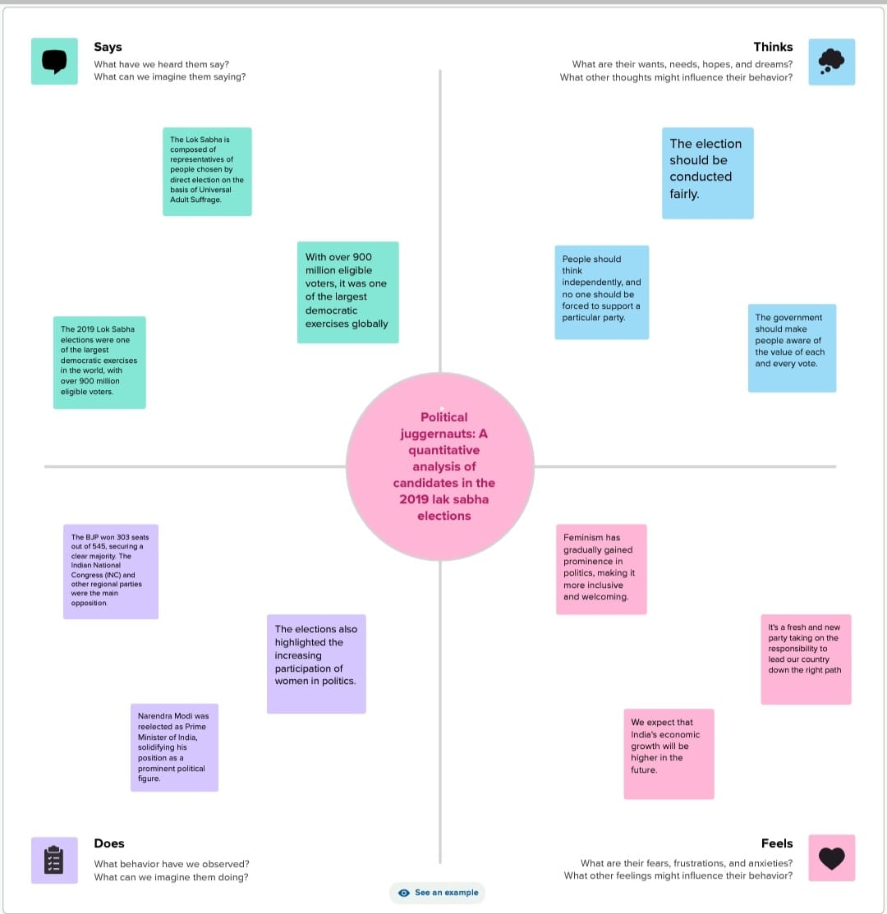
2.2 IDEATION AND BRAINSTORMING MAP
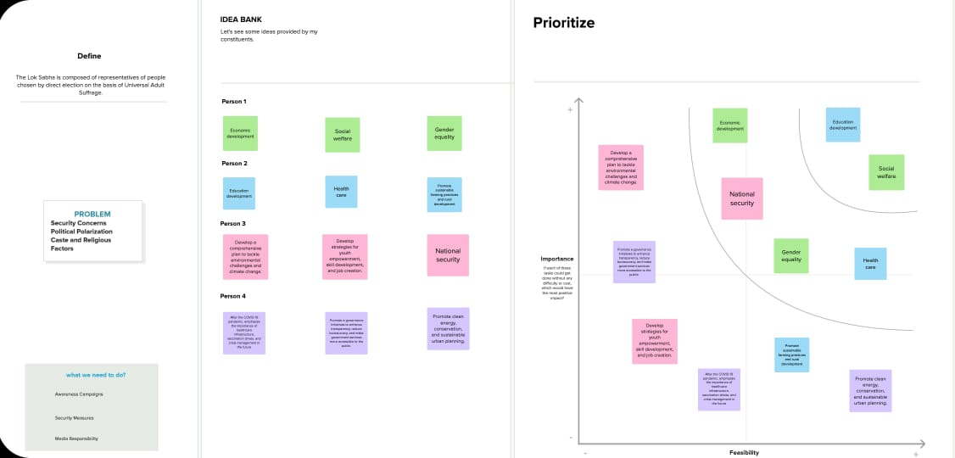

3. RESULT
SHEET 1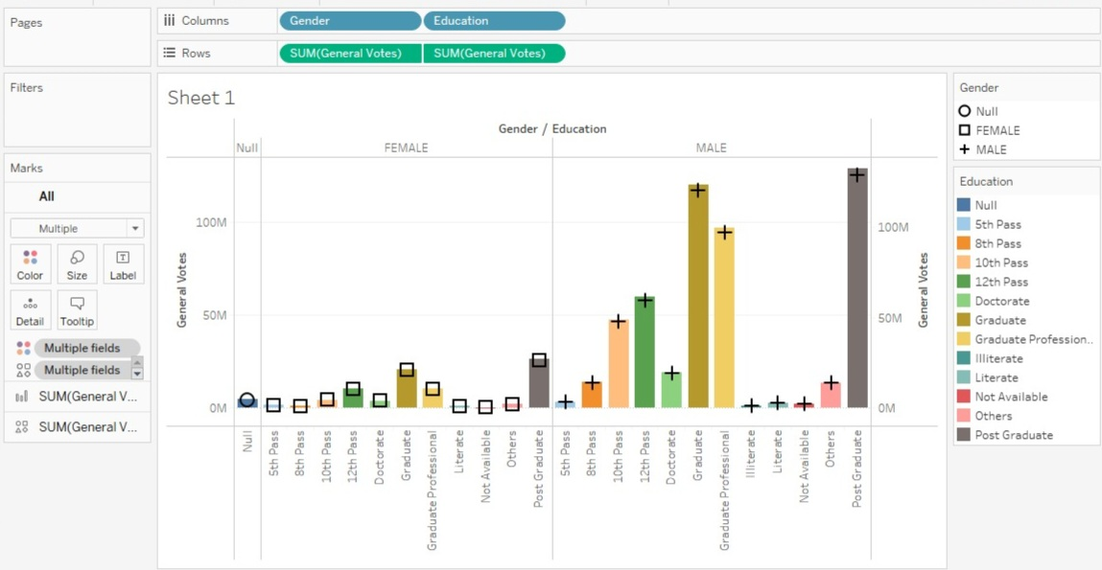

SHEET 2


SHEET 3
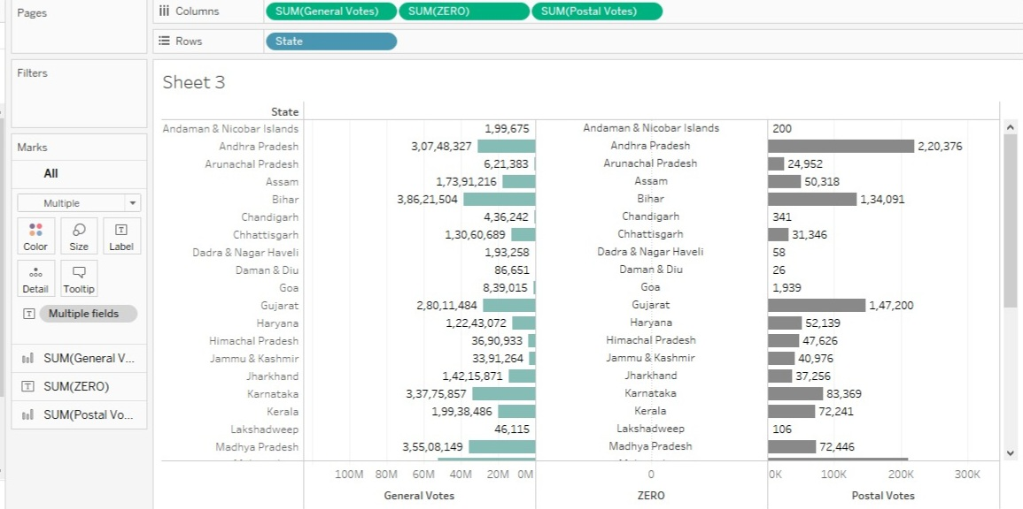
SHEET 4
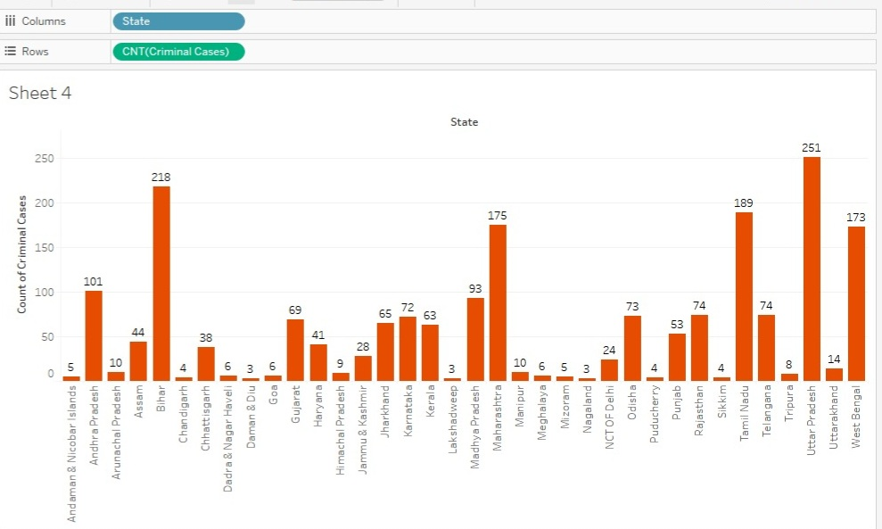

SHEET 5
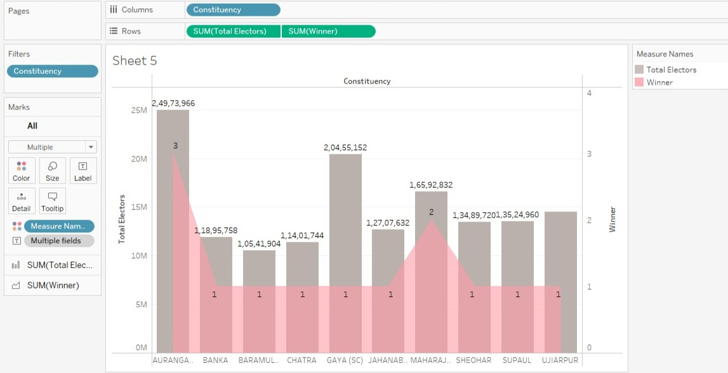
SHEET 6


SHEET 7
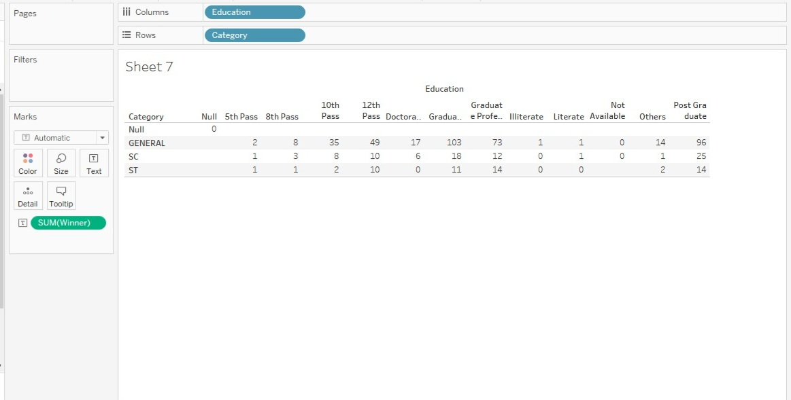
SHEET 8
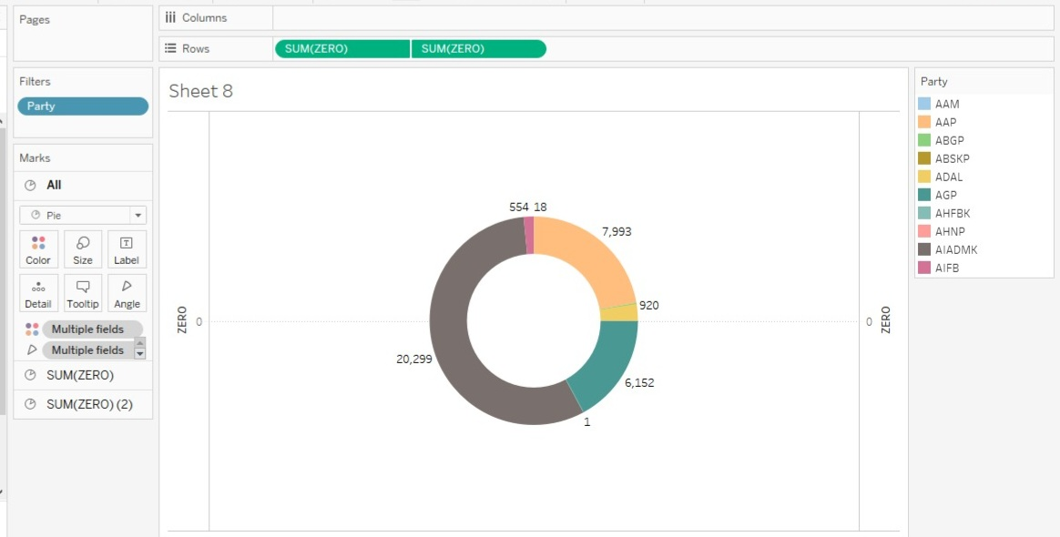

SHEET 9

SHEET 10


SHEET 11

DASHBOARD 1
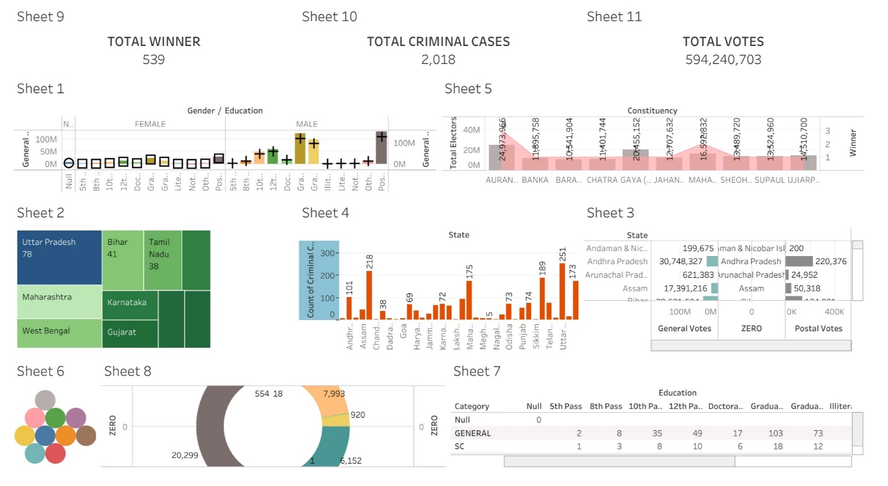

STORY
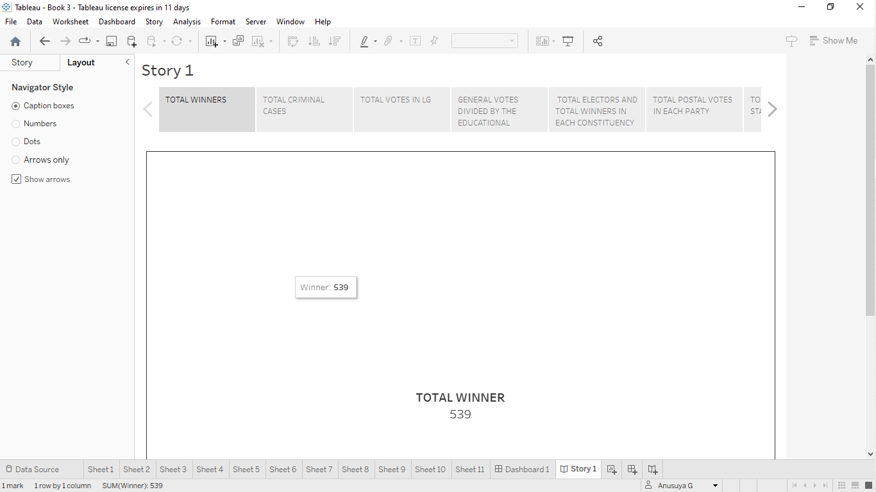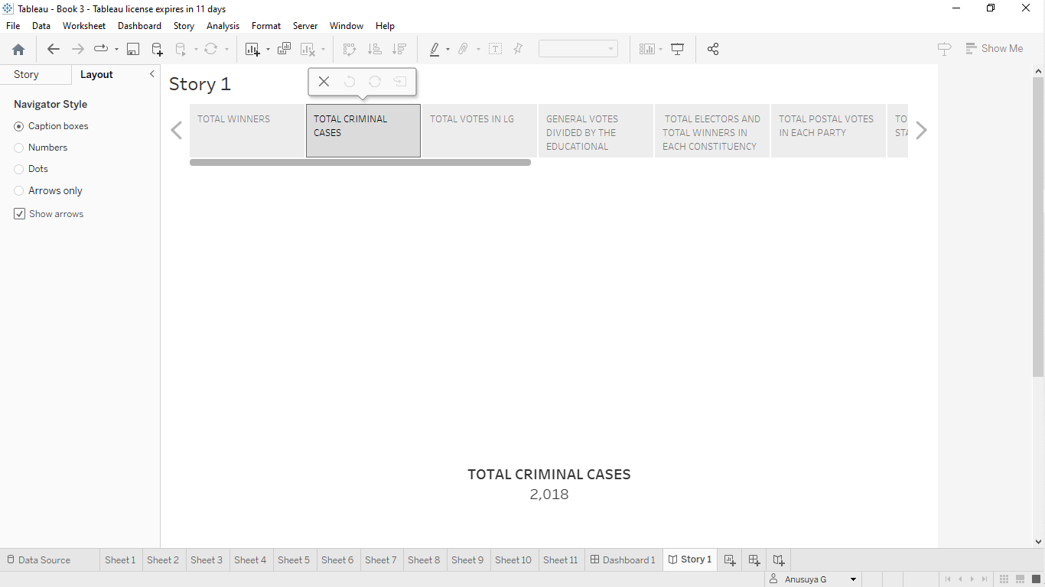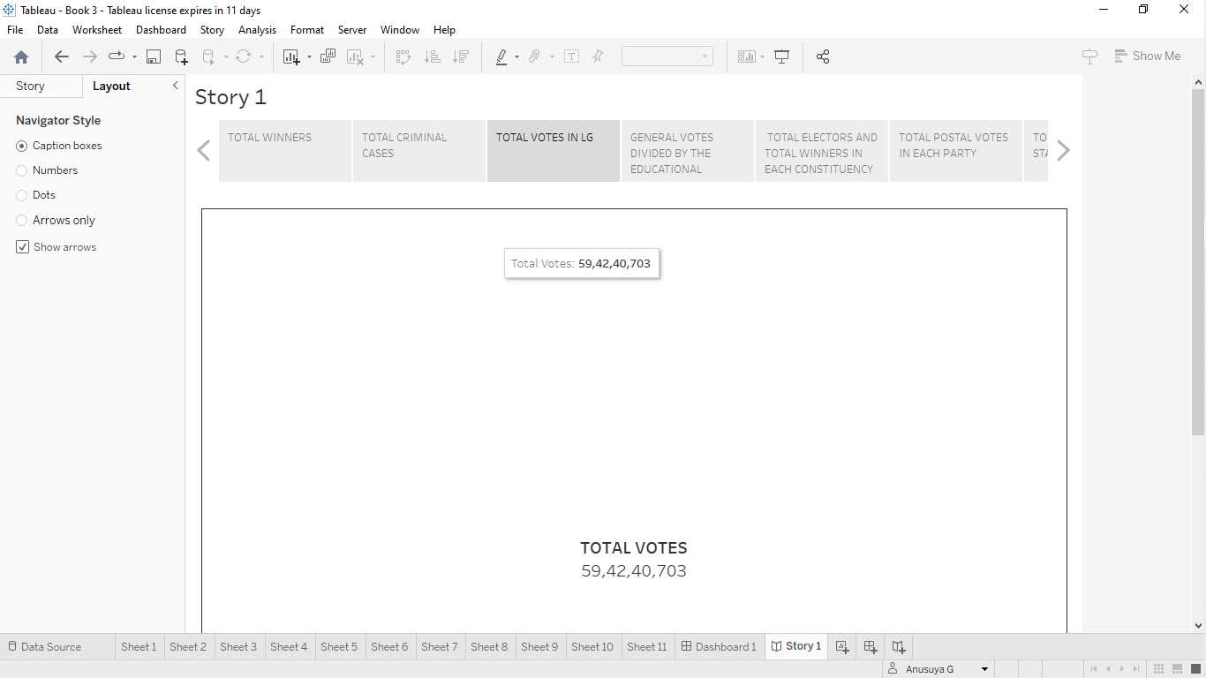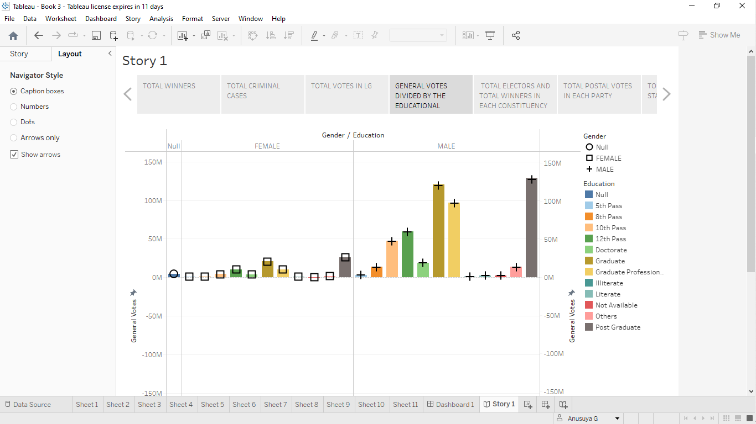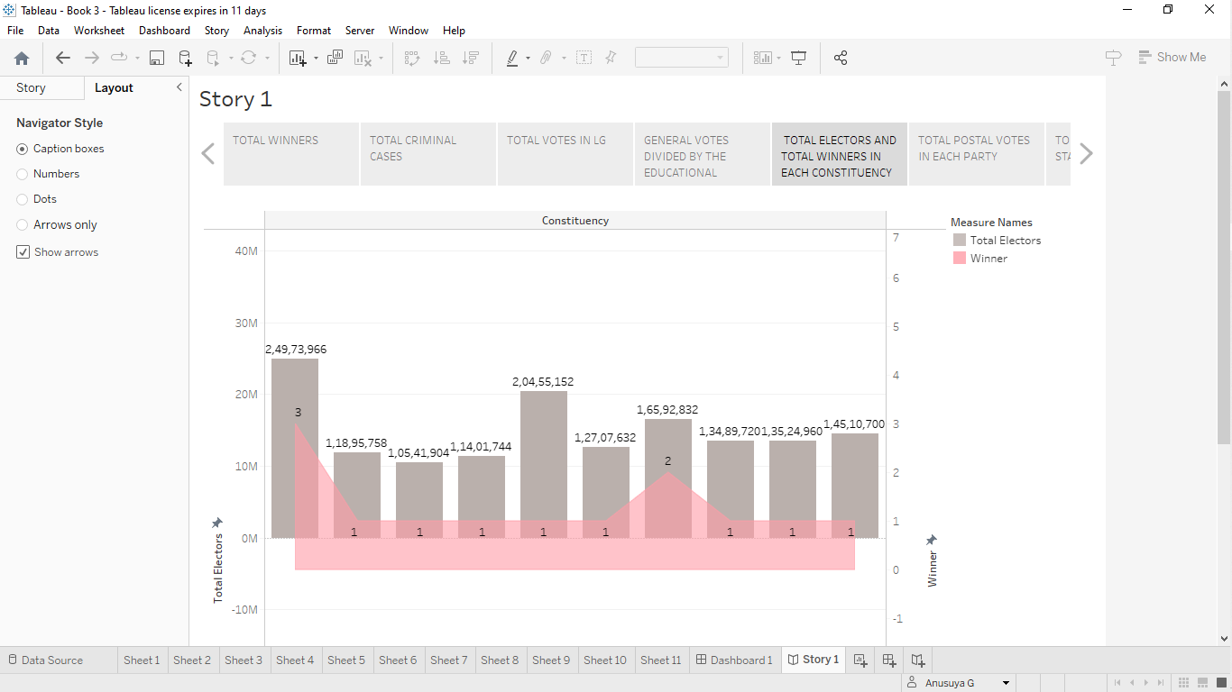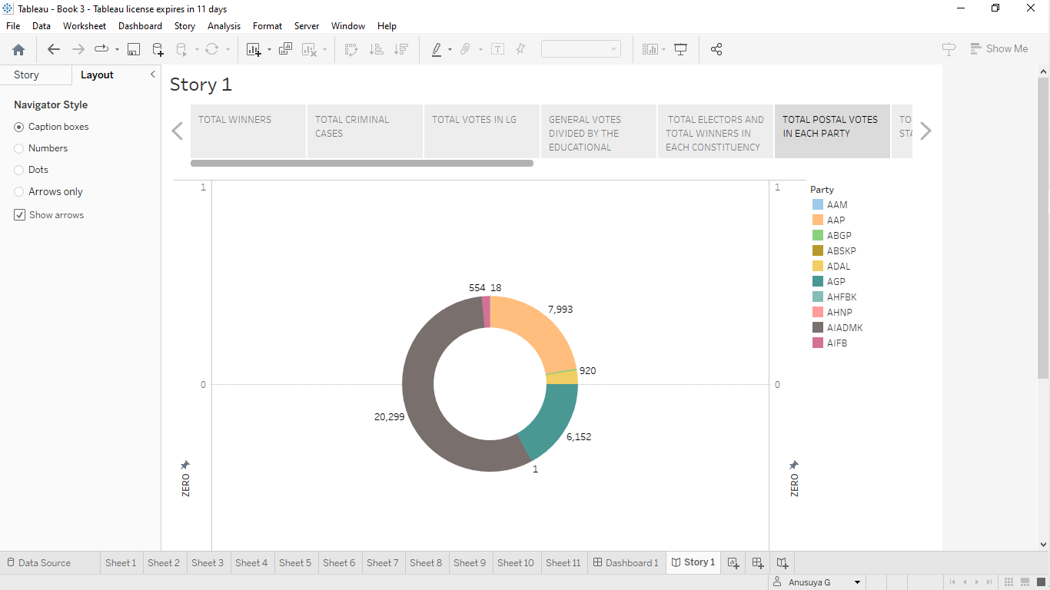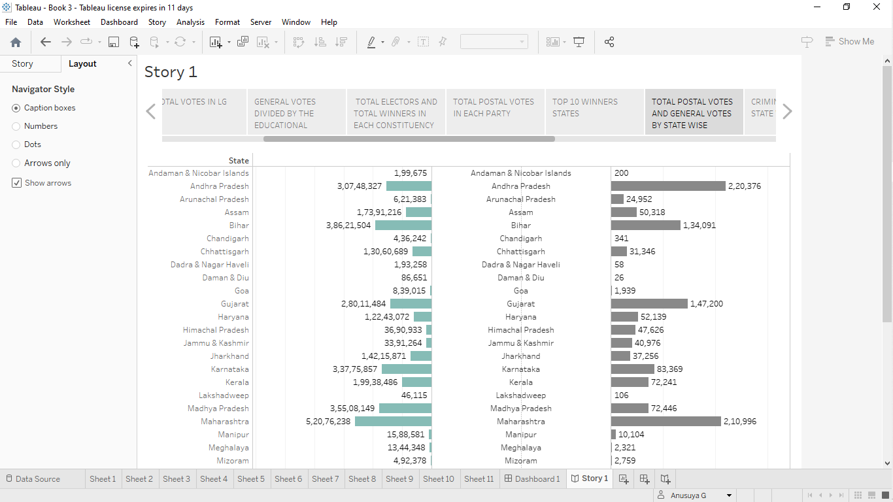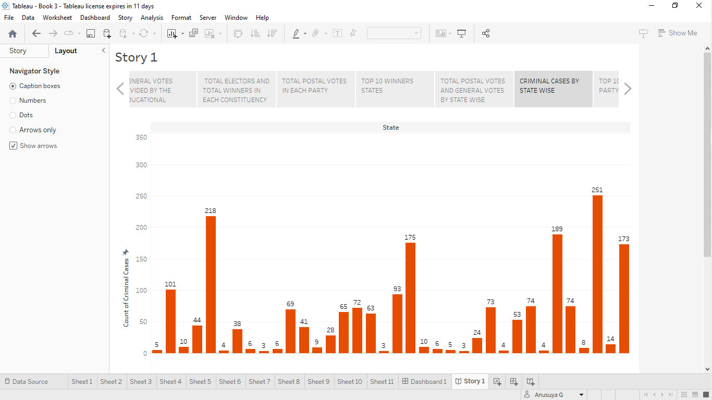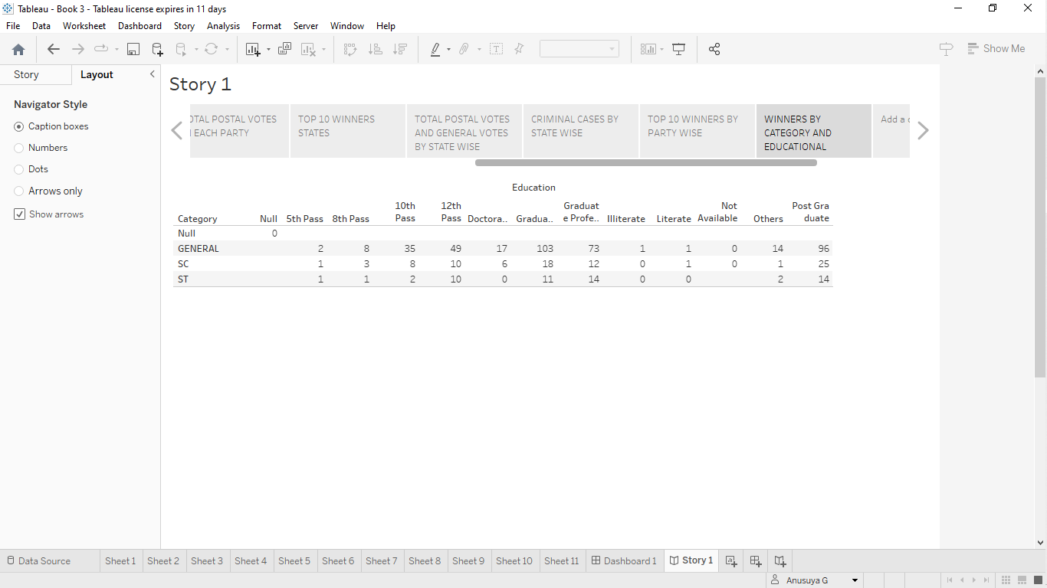

4. ADVANTAGES AND DISADVANTAGES
The 2019 Lok Sabha election in India had several advantages and disadvantages:

Advantages:
1. Democratic Process: The election allowed citizens to exercise their democratic rights by choosing their representatives through a free and fair electoral process.

2. Representation: It provided an opportunity for diverse segments of the population to elect their representatives, ensuring that different voices and viewpoints were heard.

3. Accountability: Elections hold elected officials accountable for their actions and decisions, as they can be voted out if they fail to meet the expectations of their constituents.

4. Peaceful Transfer of Power: The election demonstrated the peaceful transition of power, a fundamental aspect of a democratic system.

5. Public Participation: The election engaged millions of citizens in the political process, fostering civic participation and awareness.

Disadvantages:
1. Costly: Conducting elections, especially in a country as vast as India, is expensive and diverts resources from other important priorities.

2. Influence of Money and Corruption: Elections can be marred by the influence of money, which can lead to corruption and unethical practices.

3. Polarization: Elections sometimes lead to increased social and political polarization, with divisive rhetoric and issues coming to the forefront.

4. Manipulation: There have been concerns about voter manipulation, electoral fraud, and the misuse of resources.

5. Short Campaign Period: The limited campaign period may not provide sufficient time for candidates to effectively communicate their agendas to voters.

It's important to note that the advantages and disadvantages of elections can vary depending on the context and how they are conducted.

5. APPLICATION
Elections, such as the Lok Sabha election in India, have several important applications and purposes:

1. *Democratic Representation:* Elections are the cornerstone of a democratic system. They allow citizens to choose their leaders and representatives, ensuring that the government is accountable to the people.

2. *Decision-Making:* Through elections, voters make choices that determine government policies, laws, and decisions on various issues, shaping the direction of a country.

3. *Peaceful Transfer of Power:* Elections provide a peaceful and orderly way for one government to transition to another, preventing political upheaval and conflicts.

4. *Voice for the People:* Elections give citizens a voice in the political process, allowing them to express their preferences and concerns.

5. *Accountability:* Elected officials are held accountable for their actions and decisions by voters, who can choose to re-elect or replace them based on their performance.

6. *Representation of Diverse Views:* Elections ensure that a broad spectrum of views, ideologies, and interests are represented in the government, promoting inclusivity.

7. *Public Participation:* Elections encourage civic engagement and involvement in the political process, fostering a sense of responsibility and participation among the population.

8. *Check and Balance:* Elections provide a system of checks and balances by enabling different branches or levels of government to be elected separately.

9. *Legitimacy:* Elected governments derive their legitimacy from the electoral process, making their decisions and actions more widely accepted by the population.

10. *Transparency:* Elections are conducted openly, and the results are publicly disclosed, contributing to the transparency and fairness of the political process.

These are some of the key applications of elections in democratic societies like India. They play a crucial role in shaping the functioning of the government and the representation of the people's interests.

6. CONCLUSION
The Lok Sabha elections in India, like any democratic electoral process, are a critical cornerstone of the nation's political system. In conclusion, these elections have several significant implications:

1. *Democratic Expression:* Lok Sabha elections serve as a platform for citizens to express their democratic rights and choose their representatives.

2. *Government Formation:* The outcomes of these elections determine the formation of the central government in India, impacting policy decisions, legislation, and governance.

3. *Accountability:* Elected representatives are held accountable for their actions and decisions, as voters can decide whether to re-elect them or choose new leaders in the subsequent elections.

4. *Representation:* Lok Sabha elections ensure that diverse regions, communities, and viewpoints are represented in the national legislature, promoting inclusivity and diversity.

5. *Peaceful Transition of Power:* These elections demonstrate the peaceful transition of power, showcasing the strength and stability of India's democratic system.

6. *Public Engagement:* Lok Sabha elections engage millions of citizens, encouraging them to participate in the democratic process and fostering political awareness.

7. *Transparency and Legitimacy:* The electoral process is transparent and contributes to the legitimacy of the government, as elected officials derive their authority from the mandate of the people.

8. *Challenges and Improvements:* While the Lok Sabha elections have many advantages, they also face challenges, such as the influence of money in politics, voter manipulation, and polarization, highlighting the need for continuous improvement in the electoral process.

In summary, Lok Sabha elections in India are fundamental to the nation's democratic structure, ensuring that the government remains accountable, representative, and responsive to the diverse needs and aspirations of its citizens.

7. FUTURE SCOPE

The future scope of Lok Sabha elections (the lower house of India's Parliament) involves several key aspects:

1. Technological Advancements: Continued integration of technology for voter registration, electronic voting, and result dissemination to enhance transparency and efficiency.

2. Voter Engagement: Ongoing efforts to increase voter participation through awareness campaigns, voter education, and measures to make voting more accessible.

3. Electoral Reforms: Discussions and potential reforms in electoral processes, such as candidate selection, campaign financing, and proportional representation systems.

4. Regional Dynamics: Evolution of regional politics and the influence of state-level parties on national elections.

5. Youth Involvement: Encouraging the younger generation's active participation and understanding of the political process.

6. Women's Representation: Promoting greater gender diversity in politics and increasing the number of female representatives.

7. Coalition Politics: The role of coalition governments and alliances in shaping the political landscape.

8. Electoral Transparency: Measures to ensure fair and transparent elections, such as improved monitoring of campaign spending and reducing the influence of money in politics.

9. Social Media and Disinformation: Addressing the impact of social media on elections and efforts to combat disinformation.

The future scope of Lok Sabha elections will depend on India's evolving political, social, and technological landscape, as well as the initiatives and reforms put in place by the government and relevant authorities.

